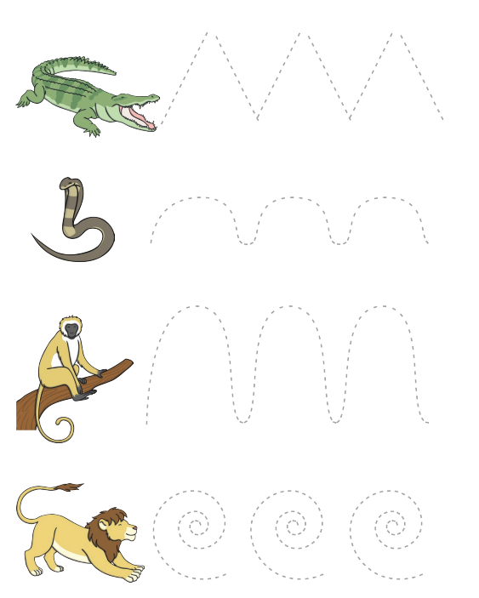Term | Autumn 1 | Autumn 2 | Spring 1 & 2 RSE Ten:Ten |  |  |  |  | Summer 1 | Summer 2
Nursery |  |  | Created and Loved by God  Story session-Handmade with love | Created to Love others  Role model  Who’s who?  You’ve got a friend in me  Forever friends  Safe inside and out  My body, my rules  Feeling poorly  People who help us |  | Created to Live in Community  God is love  Loving God, Loving others  Me, you, us |  | Relationships  My family and me  Make friends…part 1  Make friends… part 2  Falling out and bullying part 1  Falling out and bullying part 2  Being the best friends, we can be
Reception | Being Me in my World  Who…me?  How am I feeling today?  Being at school  Gentle Hands  Our rights  Our responsibilities | Dreams and Goals  Challenge  Never giving up  Setting a goal  Obstacles and support  Flight to the future  Footprint awards | Created and love by God  Story sessions- Handmade with love  I am me  Head, shoulders, knees and toes  Ready teddy?  I like, you like, we all like!  All the feelings  Lets get real  Growing up |  | Created to Love Others |  | Created to Live in Community  God is love  Loving God, loving others  Me, you, us | Healthy Me  Everybody’s body  We like to move it, move it  Food glorious food  Sweet dreams  Keeping clean  Stranger danger | Changing Me  My body  Respecting my body  Growing up  Fun and fears part 1  Fun and fears part 2  Celebration
Year 1 | Being Me in my World  Feeling special and safe  Being part of my class  Rights and responsibilities  Rewards and feeling proud  Consequences  Owning our learning charter | Celebrating Difference  Similarities and differences  Understanding bullying and knowing how to deal with it  Making new friends  Celebrating the differences in everyone | Created and love by God  Story sessions  Let the children come |  | Created to Love Others  God loves you  Special people  Treat others well…  …and say sorry  Being safe  Good and bad secrets  Physical contact  Harmful substances  Can you help me? (part 1)  Can you help me? (part 2) |  | Created to Live in Community  Three in one  Who is my neighbour?  The communities we live in | Healthy Me  Being healthy  Healthy choices  Clean and healthy  Medicine safety  Road safety  Happy, healthy me | Dreams and Goals  Setting goals  Identifying successes and achievements  Learning styles  Working well and celebrating achievements with a partner  Tackling new challenges  Identifying and overcoming obstacles  Feelings of success
Year 2 | Being Me in my World  Hopes and fears for the year  Rights and responsibilities  Rewards and consequences  Safe and fair learning environment  Valuing contributions  Choices  Recognising feelings | Celebrating Difference  Assumptions and stereotypes about gender  Understanding bullying  Standing up for self and others  Making new friends  Gender diversity  Celebrating difference and remaining friends | Created and love by God  Story sessions Let the children come  I am unique  Girls and boys  Clean and healthy (my body)  Feelings, likes and dislikes  Feeling inside out  Super Susie gets angry  The cycle of life |  | Created to Love Others |  | Created to Live in Community  Three in one  Who is my neighbour?  The communities we live in | Healthy Me  Being healthy  Being relaxed  Medicine safety  Healthy Eating part 1  Healthy Eating part 2  Happy, healthy me | Dreams and Goals  Achieving realistic goals  Perseverance  Learning strengths  Learning with others  Group co-operation  Contributing to and sharing success
Year 3 | Being Me in my World  Setting personal goals  Self-identity and worth  Positivity in challenge  Rules, rights and responsibilities  Rewards and consequences  Responsible choices  Seeing things from others perspective | Celebrating Difference  Families and their differences  Family conflict and how to manage it  Witnessing bullying and how to solve it  Recognising how words can be hurtful  Giving and receiving compliments | Created and Love by God  Story sessions get up!  The sacraments |  | Created to Love others  Story sessions Jesus my friend  Friends, family and others  When things feel bad  Sharing online  Chatting online  Safe in my body  Drugs, alcohol and tobacco  First aid heroes |  | Created to live in community  A community of love  What is the church?  How do I love others? | Healthy Me  Fit and healthy part 1  Fit and healthy part 2  Being safe  Safe or unsafe  My amazing body | Dreams and Goals  Difficult challenges and achieving success  Dreams and ambitions  New challenges  Motivation and enthusiasm  Recognising and trying to overcome obstacles  Evaluating learning processes  Managing feelings  Simple budgeting
Year 4 | Being Me in my World  Being part of a class team  Being a school citizen  Rights, responsibilities, and democracy  Rewards and consequences  Group decision- making  Having a voice  What motivates behaviour | Celebrating Difference  Challenging assumptions  Judging by appearance  Accepting self and others  Understanding influences  Understanding bullying  Problem solving  Identifying how special and unique everyone is  First impressions | Created and Love by God  Story sessions Get up!  We don’t have to be the same  Respecting our bodies  What is puberty?  Changing bodies  What am I feeling?  What am I looking at?  I am thankful  Life cycles |  | Created to Love others |  | Created to live in community  A community of love  What is the church?  How do I love others? | Healthy Me  My friends and me  Getting on and falling out  What is smoking?  What is alcohol?  Healthy friendships  Celebrating inner strength and assertiveness | Dreams and Goals  Hopes and dreams  Overcoming disappointment  Creating new, realistic dreams  Achieving goals  Working in a group  Celebrating contributions  Resilience  Positive attitudes
Year 5 | Being Me in my World  Planning the forth-coming year  Being a citizen  Rights and responsibilities  Rewards and consequences  How behaviour affects groups  Democracy, having a voice, participating | Celebrating Difference  Cultural differences and how they can cause conflict  Racism  Rumours and name calling  Types of bullying  Material wealth and happiness  Enjoying and respecting other cultures | Created and Love by God  Story sessions Calming the storm |  | Created to Love Others  Is God calling you?  Under pressure  Do you want a piece of cake?  Self-talk  Sharing isn’t always caring  Cyberbullying  Types of abuse  Impacted lifestyles  Making good choices  Giving assistance |  | Created to Live in Community  The Holy Trinity  Catholic Social Teaching  Reaching out | Healthy Me  What is Smoking? Why do people smoke?  What is alcohol? Why do people drink alcohol?  Basic emergency first aid  Body image  My relationship with food  Healthy me | Dreams and Goals  Future dreams  The importance of money  Jobs and careers  Dream job and how to get there  Goals in different cultures  Supporting others (charity)  Motivation
Year 6 | Being Me in my World  Identifying goals for the year  Global citizenship  Children’s universal rights  Feeling welcomed and valued  Choices, consequences and rewards  Group dynamics  Democracy, having a voice  Anti-social behaviour  Role- modelling | Celebrating Difference  Perceptions of normality  Understanding disability  Power struggles  Understanding bullying  Inclusion/exclusion  Differences as conflict, difference as celebration  Empathy | Created and Love by God  Story sessions Calming the storm  Gifts and talents  Girls’ bodies  Boys’ bodies  Spots and sleep  Body image  Peculiar feelings  Emotional changes  Seeing stuff online  Making babies (part 1)  Making babies (part 2) according to maturity of class  Menstruation |  | Created to Love Others |  | Created to Live in Community  The Holy Trinity  Catholic Social Teaching  Reaching out | Healthy Me  Taking responsibility for my health including mental health  What are drugs?  What is exploitation?  What are gangs?  My emotional and mental health  Managing stress and pressure | Dreams and Goals  Personal learning goals, in and out of school  Success criteria  Emotions in success  Making a difference in the world  Motivation  Recognising achievements  Compliments

Log in details for all staff- Username- akaminski@emmausmac.com
Password- SFX2022!

